Lab Report – SERIES AND PARALLEL CIRCUITS
Name, course and lab section: _________________________________________

Part I – Series Circuits
In Figure 1 below, we have two resistors wired in series with one another. The red and black clips in the figure are connected to a voltmeter, and the icon labeled “I” is an ammeter, which is wired in series with the resistors. The box labelled “V” is the power supply, which is supplying the total voltage to the circuit.
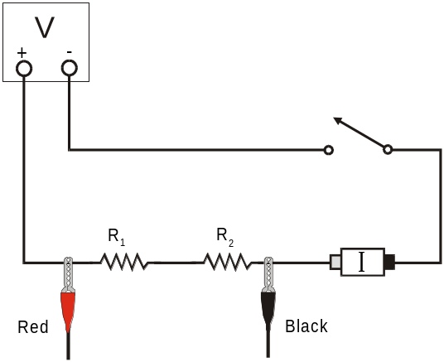
Figure 1

You have gone into the lab to find that someone has done current and voltage measurements for these resistor combinations already. The voltage across just resistor R₁ is found in the column for V₁; the voltage across just resistor R₂ is found in the column for V₂. The current through the circuit is found in the column for I.
Part I: Series circuits |  |  |  |  |  |  |  | R_{eq}  (Using the rule for series resistors)  (Ω)
 | R₁  (Ω) | R₂  (Ω) | I  (A) | V₁  (V) | V₂  (V) | V_{TOT}  (V) | R_{eq}  (Ohm Law)  (Ω) | R_{eq}  (Using the rule for series resistors)  (Ω)
1 | 10 | 10 | 0.251 | 2.519 | 2.498 | 5.00
2 | 10 | 33 | 0.117 | 1.187 | 3.826 | 5.00
3 | 33 | 33 | 0.076 | 2.511 | 2.502 | 5.00

- In the column that says R_{eq} (Ohm’s Law), use Ohm’s Law to calculate the equivalent resistance for the circuit. Show your calculations, and place your answers in the table.

- In the column that says R_{eq} (using the rule for series resistors), use that rule to fill in values for the column. Show your calculations, and place your answers in the table.
PART I – ANALYSIS
- Examine the results of Part I. What is the relationship between the three voltage readings: V1, V2, and VTOT?
- For each of the three series circuits, compare the experimental results with the resistance calculated using your rule. Calculate the percent difference for each row, and report each here, showing your calculations.
Percent difference is used for comparing two experimental values x₁ and x₂:
% difference $= \frac{\left|x_{1}-x_{2}\right|}{x_{1}+x_{2}}×200\%$
Note that the “200%” comes from the fact that in the denominator of the formula, we are really comparing with the average of x₁ and x₂.

Part II – Parallel circuits
In the circuit below, you can see that someone has created Figure 2, showing the connections for a parallel circuit. As in the previous circuit, the red and black clamps are used to show where we measure the voltage applied to both resistors. The “I” indicates where we have inserted the ammeter to measure the total current.
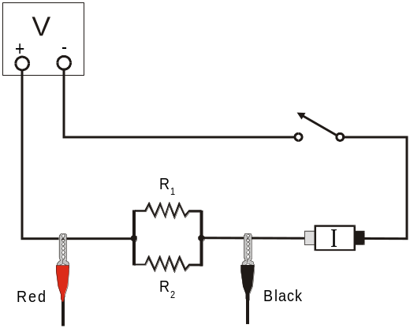
Figure 2

In the table below, you can see that again, someone has taken current and voltage readings for the circuit, using different values for the two resistors.

Part II: Parallel circuits |  |  |  |  |  |  |  | R_{eq}  (Using the rule for parallel resistors)  (Ω)
 | R₁  (Ω) | R₂  (Ω) | I  (A) | V₁  (V) | V₂  (V) | V_{TOT}  (V) | R_{eq}  (Ohm Law)  (Ω) | R_{eq}  (Using the rule for parallel resistors)  (Ω)
1 | 33 | 33 | 0.309 | 5.00 | 5.00 | 5.00
2 | 33 | 47 | 0.262 | 5.00 | 5.00 | 5.00
3 | 47 | 47 | 0.215 | 5.00 | 5.00 | 5.00

- In the column that says R_{eq} (Ohm’s Law), use Ohm’s Law to calculate the equivalent resistance for the circuit. Show your calculations, and place your answers in the table.

- In the column that says R_{eq} (using the rule for parallel resistors), use that rule to fill in values for the column. Show your calculations, and place your answers in the table.
PART II – ANALYSIS
- Examine the results of Part II. What is the relationship between the three voltage readings: V1, V2, and VTOT?
- For each of the three parallel circuits, find the percent difference between your two values of the equivalent resistance. Show your calculations.

Part III – Currents in a Series circuit
In Figure 3 below, we have two resistors in series, and there is an ammeter in between the resistors as well as an ammeter to the right of the 47 ohm resistor.
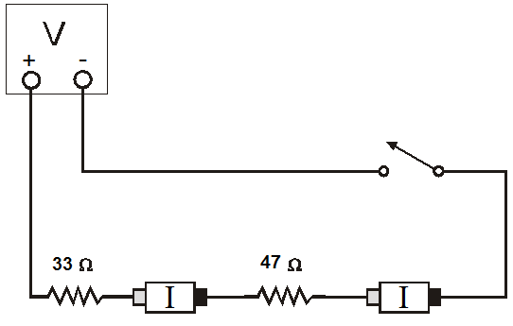
Figure 3

- Determine what the values of the current will be for each of the following empty cells in the table below. Show your calculations and/or explain how you determined what values for current go in each cell.

Part III: Currents in Series
 | R1 (Ω) | R2 (Ω) | I₁ (A) | I₂ (A) | I_{Source} (A)
Series | 33 | 47

Part IV – Currents in a Parallel Circuit
In Figure 4 below, we show circuit diagrams in which we have connected a parallel circuit using the 33 ohm resistor and the 47 ohm resistor. In the left panel we show the circuit with two ammeters, one wired in series with each of the two resistors, which will measure the current through each resistor individually. In the right panel, a single ammeter is placed after the parallel resistor combination, in order to measure the total current output from the voltage source.
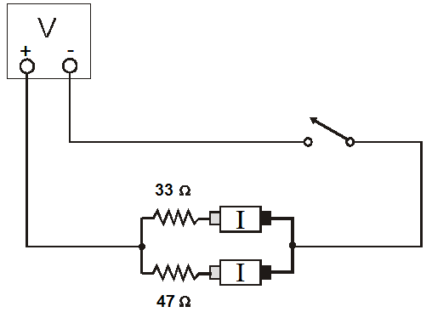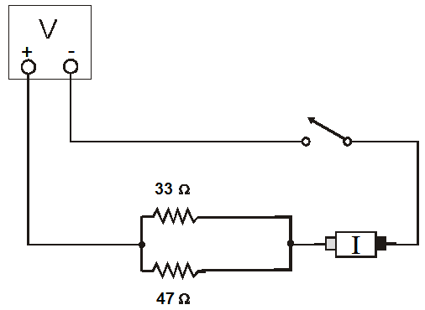
Figure 4

- Determine what the values of the current will be for each of the following empty cells in the table below. Show your calculations and/or explain how you determines what values for current go in each cell.
Part IV: Currents in Parallel
 | R1 (Ω) | R2 (Ω) | I₁ (A) | I₂ (A) | I_{Source} (A)
Parallel | 33 | 47

PARTs III-IV – ANALYSIS
- What did you discover about the relationship between the currents flowing through two resistors connected in a series (Part III)? How do those currents compare with the current from the voltage source?
- What did you discover about the relationship between the currents flowing through two resistors connected in parallel (Part IV)? How do those currents compare with the current from the voltage source?
- If the two measured currents in your parallel circuit were not the same, which resistor had the larger current going through it? Why?
Part V – A Combination Circuit
The previous lab occupant left a diagram of one final circuit that involves both series and parallel connections – but they did not write down any measurements. Use the questions and table below to predict what the resulting values for this circuit would be.
Reminder: Be sure to show your calculations at every step!
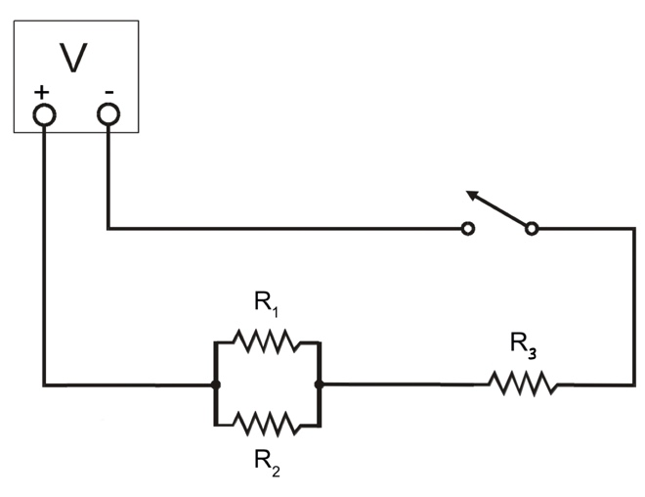
Figure 5

- Use the rules for series and parallel resistors (as appropriate) to find:
  - the equivalent resistance of resistors R₁ and R₂: R₁₂ = ___________ Ω
  - the equivalent resistance of the whole circuit: R_{eq} = ___________ Ω
- Use Ohm’s Law to predict the total current being supplied by the power source. Assume that the power source is set to a voltage of 5.000 V. Then, use the rules for current in series or parallel circuits (as appropriate) to predict the current through resistor R₃, and enter that value in the table below.
I_{source} = _________ A

- Use Ohm’s Law to predict the voltage across resistor R₃. Then, use the rules for voltage in series and parallel circuits (as appropriate) to predict the voltages across resistors R₁ and R₂. Write all of these predictions into the table below.
- Use Ohm’s Law to predict the currents passing through resistors R₁ and R₂, and enter the values in the table below.
Part V: A Combination Circuit
Resistors | Voltage across  that Resistor | Current through  that Resistor
R₁ = 10 Ω
R₂ = 47 Ω
R₃ = 33 Ω

- Now that you’ve fully predicted the parameters of the circuit, the scribblings of your predecessor make more sense. You see now that they measured the voltage and current for resistor R₂ to be 1.008 V and 0.021 A, respectively. Calculate the percent difference between your predictions and these measurements.
- How would you repeat the measurements your predecessor made on resistor R₂? Explain in words below, and also draw/label the voltmeter and ammeter placements on Figure 5.

